APPLICATION FOR A MINOR EXEMPTION

PUBLIC NOTICE is hereby given that the City of Westmount shall consider an application for a minor exemption at the regular sitting of the Municipal Council to be held on July 7th, 2025, at 7:00 p.m. in the Council Chamber, at City Hall, located at 4333 Sherbrooke Street West, Westmount, which shall be broadcast live on the City's website. The link to the sitting will be available at the following address: www.westmount.org/council-live

Location of the request:

392, Victoria Avenue (lot 1 581 439)

Nature of the request:

The request for a minor exemption is aimed at allowing the installation of a free-standing deck that would occupy the entire side yard of lot 1 581 439, that would not be supported by posts or walls and that would require the elimination of six parking spaces, which will not be conforming to the following sections of Zoning By-law 1303:

- Section 5.5.1 stipulates at point (4) that “in the case of a building other than a residential or industrial building or in the case of a part of a building designed for occupancies other than residential, a parking garage on the lot or parcel of land on which the building is constructed is established containing a minimum of one parking space per 500 square feet (46.45 square metres) of the ground floor area is established, and one parking space per 1,000 square feet (92.90 square metres) of the total floor area of all other floors”, which would require seven (7) parking spaces on the lot 1 581 439 after calculation;

- Section 6.17.2 stipulates that a free-standing deck is “a deck supported by posts or walls, but structurally separate and connected to the building only by a walkway or staircase less than 4.92 feet (1.50 meter) wide, is not considered part of the building”, and that “the distance between a deck and a property line shall be at least twice as great as its height above the ground”.

Any interested person may be heard by Council regarding this request at the sitting or during the live broadcast of the sitting on the City's website. Any interested person may also submit questions or comments via the online form: https://westmount.org/en/questions-for-the-council-meeting.

For more information, please contact the front counter of the Urban Planning Department in person, by phone at 514 989-5200, or by email at permis@westmount.org.

GIVEN at Westmount, this Friday, June 17th, 2025.

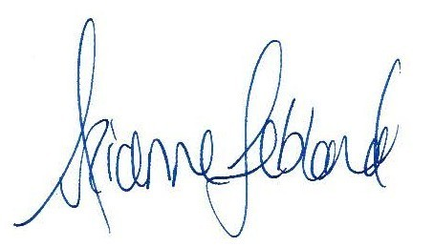

Me Arianne Leblond
Assistant City Clerk

